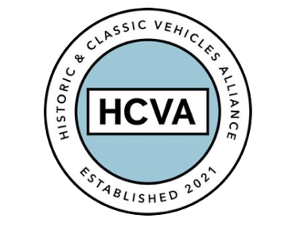

FOR IMMEDIATE RELEASE
From the HCVA

9th May 2024

CALL FOR EVIDENCE ON HOW TO “FUTURE-PROOF CLASSIC CARS AND BACK DRIVERS.”

SECRETARY OF STATE FOR TRANSPORT MARK HARPER MAKES ANNOUNCEMENT AT BICESTER HERITAGE

Bicester, Oxfordshire 9th May 2024 – Mark Harper, Secretary of State for Transport, visited Bicester Heritage today to announce a public call for evidence into the way Historic vehicles are handled by the DVLA. The meeting, hosted by HCVA, included a tour of technical businesses on-site and a chance for the Secretary of State to experience a selection of Historic cars on the test track.

Mark Roper, HCVA Chair and Managing Director of Hagerty International said “today’s announcement by the Secretary of State sets a really positive new direction for the future handling of Historic vehicle registrations by DVLA.”

He anticipates the sector’s relationship with the government agency will become easier in future as a result of changes following responses to the call for evidence: “We look forward to agreeing new policy clarifications that detail exactly how our members can be sure of retaining a vehicle's Historic status, especially during restoration. As ever, industry is standing by to help develop these clarifications.”

HCVA will be providing a full response to the document in due course, and providing guidance to enable members to do likewise.

The response period is open from now until 4th July.

http://www.gov.uk/government/calls-for-evidence/registering-historic-classic-rebuilt-vehicles-and-vehicles-converted-to-electric-call-for-evidence

ENDS

About HCVA

Established in 2021, the Historic and Classic Vehicles Alliance is a not-for-profit trade organisation founded to represent the collective voice of SMEs within the historic and classic vehicle sector, supported by individual owners and enthusiasts.

Through collaboration, transparency, and proactive lobbying the HCVA seeks to increase awareness and education of the sector's economic and social benefits, to ensure those responsible for policy and regulation are challenged and held accountable, to promote sustainable innovation and technologies, and to ensure the HCVA member community is engaged and confident their voices will be heard.

For more information, please contact:

Shân Stokes
Email: press@hcva.co.uk
Phone: 01869 934525

