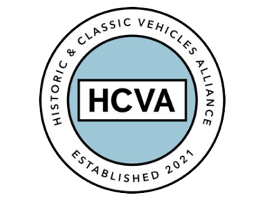

FOR IMMEDIATE RELEASE
From the HCVA Board of Directors

8th May 2024

HCVA LEADERSHIP CHANGES

Bicester, Oxfordshire 8th May 2024 – Spring is often a time of change, and there is a change to announce at the HCVA. Our Chairman, David Meek, has decided to move on to new ventures following a fantastic year of growth and renewal at the HCVA. The Board of Directors thank him for all he has brought to the organisation during his tenure. His own passion for classic cars has underpinned his hard work and determination to affect positive change over the past year and we collectively wish him well for his next endeavours.

Taking his place as Chairman is current Board Member, Mark Roper. Mark is also Managing Director of Hagerty International. Mark brings a wealth of experience in leading teams, driving growth in organisations and building membership and engagement.

In addition to Mark’s appointment, the Board has decided the time is right to bring in a new Chief Executive Officer to lead the future strategy and day to day activities of the HCVA. The recruitment process will commence shortly and naturally we welcome candidate suggestions from the membership. The CEO is a full time, remunerated role and the incumbent will need to have experience of policy and regulation, government lobbying as well as P&L management, leadership and program delivery.

Since its creation in 2021 the HCVA has been front and centre of the debate around the issues our classic car industry faces.

Providing robust challenge on specific areas of government policy, supporting our partners important work and messaging in the heritage skills sector to ensure there is a skilled workforce for the future, focusing on the sustainability of our beloved vehicles and how best to power them long term and creating an open minded networking facility for businesses old and new in our industry to meet, learn from each other and crucially do more business as a result.

We know all of these areas are imperative to our members and so we want to provide reassurance that this focus and determination will continue under the stewardship of the existing and future leadership team.

We look forward to the next stage of the HCVA’s growth and development, with the members at the forefront of all we strive to achieve.

ENDS

About HCVA

Established in 2021, the Historic and Classic Vehicles Alliance is a not-for-profit trade organisation founded to represent the collective voice of SMEs within the historic and classic vehicle sector, supported by individual owners and enthusiasts.

Through collaboration, transparency, and proactive lobbying the HCVA seeks to increase awareness and education of the sector's economic and social benefits, to ensure those responsible for policy and regulation are challenged and held accountable, to promote sustainable innovation and technologies, and to ensure the HCVA member community is engaged and confident their voices will be heard.

For more information, please contact:

Shân Stokes
Email: press@hcva.co.uk
Phone: 01869 934525

