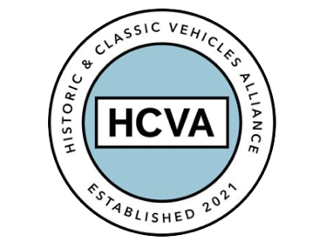

FOR IMMEDIATE RELEASE

19th March 2024

The HCVA is pleased to announce that Jaguar Land Rover Classic has joined the organisation as a Trade Member

Bicester, Oxfordshire 19th March 2024 – Bicester-based trade association the
Historic & Classic Vehicles Alliance is is pleased to announce that Jaguar Land Rover Classic has joined the organisation as a Trade Member.

HCVA expects JLR to be the first of several manufacturers to join the Trade Body which represents the £18B industry relied upon by Classic and Vintage motoring enthusiasts.

David Meek, HCVA Chair says:

"We are delighted to welcome JLR Classic into the membership. Manufacturers are an important part of the Classic ecosystem, and it's exciting that JLR recognises that they have a valuable role to fulfil via their membership of the HCVA."

Paul Barritt, Director of JLR Classic said:

"We look forward to strengthening our links with other Classic aftermarket and restoration businesses, and to working closely with fellow HCVA members to grow our combined presence in this unique sector for the benefit of our mutual customers worldwide."

ENDS

About JLR Classic

JLR Classic is a division of JLR established for the maintenance, sales and general promotion of Heritage Jaguar and Land Rover vehicles. The state-of-the-art facility was established in 2017 and is located near Coventry, the birthplace of Jaguar.
In addition to offering used examples of Heritage Vehicles, JLR Classic performs full restorations under their ‘Reborn’ program as well as exclusive continuation projects for some of the most iconic JLR vehicles including the D-type and E-type Lightweight. JLR Classic also reproduces a huge range of genuine parts, ensuring a long term future for these important Heritage Vehicles.

About HCVA

Established in 2021, the Historic and Classic Vehicles Alliance is a not-for-profit trade organisation founded to represent the collective voice of SMEs within the historic and classic vehicle sector, supported by individual owners and enthusiasts.

Through collaboration, transparency, and proactive lobbying the HCVA seeks to increase awareness and education of the sector's economic and social benefits, to ensure those responsible for policy and regulation are challenged and held accountable, to promote sustainable innovation and technologies, and to ensure the HCVA member community is engaged and confident their voices will be heard.

For more information, please contact:

Shân Stokes
Email: press@hcva.co.uk
Phone: 01869 934525

