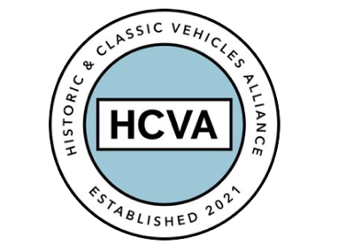

FOR IMMEDIATE RELEASE

19th February 2024

HCVA TAKES ACTION ON CLASSIC VEHICLE PARTS QUALITY

Bicester, Oxfordshire 19th February 2023 – Bicester-based trade association the
Historic & Classic Vehicles Alliance is seeking information from its professional members about the quality of classic vehicle parts used in the restoration and maintenance of classic cars and vehicles.

If a component fitted by a restorer or maintainer doesn't fit properly or fails
prematurely, the resulting rectification can impose costs onto the installer far beyond the value of the part that failed – not to mention consequential reputational harm and customer dissatisfaction.

No-one deliberately supplies substandard parts, so the HCVA's 'Action on Parts’ programme exists to collect data and initiate constructive dialogue between all parties to investigate feasible improvements - perhaps a minor redesign or material change - as well as their commercial ramifications.

The process is initiated online, where HCVA members identify parts causing problems, and importantly also suggest improvement proposals of their own.

Cases are then taken forward in a non-confrontational round-table format involving all involved parties, where proposals can be discussed in a professional, co-operative environment. By working together in this way, HCVA hopes that supplying and installing companies can improve the landscape of parts supply for the benefit of themselves, their fellow professionals, and enthusiasts alike.

HCVA Executive Director Guy Lachlan says:

“We are really lucky to have a diverse array of parts suppliers in the UK, which makes this country the best place to own and use a classic vehicle.

Action on Parts will help to address areas where perhaps five or ten pounds extra cost on a part can save tens or hundreds of hours in unnecessary warranty work down the line. It really is a win/win/win for manufacturers, installers and enthusiasts.”

Julian Barratt of SNG Barratt Ltd, a Founding Partner of the HCVA and leading Jaguar parts supplier, welcomes the initiative.

"The HCVA's Action on Parts program will help us to identify product improvement opportunities with feedback from expert installers, get feedback on our proposals, and take action where mutually appropriate. It's an important step, and one in which the HCVA can play an important facilitative role."

ENDS

About HCVA

Established in 2021, the Historic and Classic Vehicles Alliance is a not-for-profit trade organisation founded to represent the collective voice of SMEs within the historic and classic vehicle sector, supported by individual owners and enthusiasts.

Through collaboration, transparency, and proactive lobbying the HCVA seeks to increase awareness and education of the sector's economic and social benefits, to ensure those responsible for policy and regulation are challenged and held accountable, to promote sustainable innovation and technologies, and to ensure the HCVA member community is engaged and confident their voices will be heard.

For more information, please contact:

Shân Stokes
Email: press@hcva.co.uk
Phone: 01869 934525

