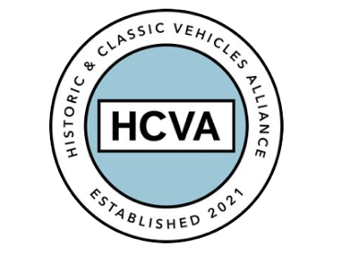

FOR IMMEDIATE RELEASE

20/10/2023

HISTORIC MOTORING CHARITY HOSTS LOCAL SCHOOL CAREERS DAY

Bicester, Oxfordshire 20th October 2023 – Bicester-based charity, StarterMotor has hosted an inspirational careers day for a local school.

The event saw over 180 Year 9 students and their teachers gather at the charity’s headquarters at Bicester Heritage to enjoy a full programme of presentations and hands-on experience of the classic car industry.

StarterMotor is an organisation focused on introducing the next generation of young people to historic and classic vehicles, the many related careers and a diverse range of associated events by providing free resources to individuals and working with academic establishments and apprenticeship schemes.

The day’s workshop sessions encompassed interactive talks, engaging discussions, and informative demonstrations tailored to showcase the dynamic and multifaceted aspects of working within the classic car sector.

Students had the opportunity to interact with industry professionals, including seasoned veterans and young enthusiasts who have successfully built careers in the field.

David Withers, StarterMotor CEO said, “It’s just fantastic to see young people's faces light up as they walk around Bicester Heritage and see beautiful old cars in motion for the first time, even better when one of our Ambassadors is behind the wheel. That’s what we’re trying to do here at StarterMotor: spark a passion for historic vehicles in the next generation so that the industry we know and love has a bright future.”

The charity works in partnership with the Historic and Classic Vehicles Alliance (HCVA), one of Britain’s leading automotive trade bodies known for advocating the preservation, promotion, and enjoyment of historic and classic vehicles.

David Meek, Chair of HCVA said: "We believe that introducing school students to the various career options within this vibrant industry will not only ignite their interest but also contribute to the growth and sustainability of the classic car sector.”

Investing in the next generation of historic car enthusiasts and encouraging them to consider the abundant career paths available in the classic car industry is a shared goal of both parties, alongside igniting their passion for the preservation and restoration of historic vehicles.

“I couldn’t believe that some of the cars I saw at Bicester today were nearly 100 years old and still worked! I understand now that there are loads of chances to get a job in places like Bicester in the future, even if it’s not actually fixing cars.” Said one Year 9 Student at the careers day.

By empowering local students with knowledge and insights into potential career paths, this event plays a vital role in shaping the future of the classic car industry.

ENDS
For more information, please contact:

Libby Raynsford
Director of Marketing and Communications

Email: libby@hcva.co.uk
Phone: 07525 372631

