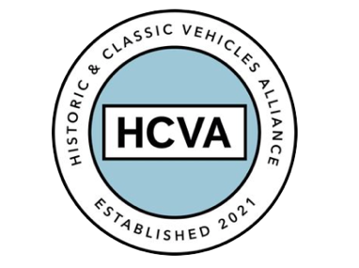

FOR IMMEDIATE RELEASE

06/10/2023

HISTORIC AND CLASSIC VEHICLES ALLIANCE
CELEBRATES INAUGURAL HERITAGE MATTERS INSIGHTS DAY

Bicester, Oxfordshire 6th October 2023 – The Historic and Classic Vehicles Alliance (HCVA), one of Britain’s leading automotive trade bodies known for advocating the preservation, promotion, and enjoyment of historic and classic vehicles, has celebrated its first ‘Heritage Matters’ Trade Members’ Insights Day.

The event, held at Hagerty’s UK Clubhouse at Bicester Heritage, offered an invaluable opportunity for HCVA’s trade members to enjoy an inspirational and informative day of industry discussion and networking.

Hosted by motorsports broadcaster Toby Moody, proceedings began with HCVA’s Chair, David Meek, presenting the organisation’s strategic vision. The day’s agenda focused on five key areas and a keynote speech from Greg Smith MP.

- Education and Skills: Securing our industry’s future
Speakers: David Withers, CEO of StarterMotor, Ross Hedigan, Business Development for StarterMotor, John Pitchforth, founder of Heritage Skills Academy and Dan Geoghegan, CEO of Bicester Motion

- Regulation and Policy: Challenges and Opportunities
A discussion hosted by HCVA Chair David Meek with Dudley Ashford and Gareth Jones, from DVLA Corporate Services

- Environment and Sustainability: Future liquid fuels
Speaker: Guy Lachlan, HCVA board member

- Classic Car Values: Market update and industry implications
Speaker: John Mayhead, editor, Hagerty Price Guide

- Industry Outlook: Roundtable interview hosted by Toby Moody
Panel: Sarah Thomas, Commercial Director at Car and Classic, Greg Smith MP, author Paul Griffin, Guy Lachlan, HCVA Board Member and Ross Hedigan, Business Development at StarterMotor

The inaugural Heritage Matters Day was attended by circa 100 HCVA trade members and guests and will become a regular event for the not-for-profit organisation.

HCVA Chair, David Meek says: “HCVA represents the one voice of all those who earn a living in the classic and historical vehicle sector, a not-for-profit organisation without bias, independent and pragmatic. Our inaugural insights day was an important milestone in our vision, demonstrating our collaborative and solutions based approach towards proactive problem solving for the sector. The feedback has been excellent and we are already planning the next event.”

Since its inception, the HCVA has worked tirelessly to preserve the UK’s rich legacy of historic and classic vehicles, while also making significant strides in safeguarding automotive heritage and inspiring future generations.

HCVA’s Heritage Matters Insights Day further demonstrates its commitment to supporting the classic car sector.

For more information about HCVA and its members, visit our website: www.hcva.co.uk

ENDS

About HCVA

Established in 2021, the Historic and Classic Vehicles Alliance is a not-for-profit trade organisation founded to represent the collective voice of SMEs within the historic and classic vehicle sector, supported by individual owners and enthusiasts.
Through collaboration, transparency, and proactive lobbying the HCVA seeks to increase awareness and education of the sector's economic and social benefits, to challenge and hold accountable those responsible for policy and regulation, to promote sustainable innovation and technologies, and to ensure the HCVA member community is engaged and confident their voices will be heard.

For more information, please contact:

Libby Raynsford
Director of Marketing and Communications

Email: libby@hcva.co.uk
Phone: 07525 372631

