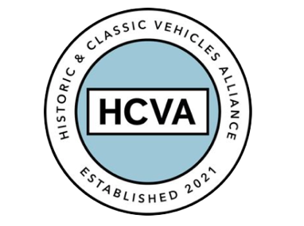

FOR IMMEDIATE RELEASE

02/10/2023

HISTORIC AND CLASSIC VEHICLES ALLIANCE
WELCOMES NEW BOARD DIRECTORS

Bicester, Oxfordshire 2nd October 2023 – The Historic and Classic Vehicles Alliance (HCVA), one of Britain’s leading automotive trade bodies known for advocating the preservation, promotion, and enjoyment of historic and classic vehicles, has welcomed three new board members.

The appointment sees Mark Roper, David Withers and Erik Olsen join the HCVA Board of Directors, alongside David Meek (Chair), Henry Pearman, Guy Lachlan and Emma Crickmay.

The three bring a wealth of experience to further enhance the governance and expertise across the Alliance’s strategic objectives.

Joining the HCVA Board of Directors are:

Mr Mark Roper – Non-Executive Director
Mark has had a long and esteemed career within Financial Services, Loyalty and Membership. On leaving education he joined a management intake at Lloyds Bank, one of the UK’s largest financial institutions. He rose to become Head of Loyalty, managing programs for the banks most valuable clients.

At American Express he held a number of senior leadership positions across B2B an B2C, culminating in running the UK and Nordics Merchant Services business. At Aon, Mark led the UK Consumer, Private Client and SME businesses building affinity and membership through insurance.

More recently, he joined Hagerty, where he is Managing Director of the UK business and is also charged with growing Hagerty’s presence into Europe.

Mr David Withers – Non-Executive Director
David is CEO of StarterMotor, the historic car charity with a mission to introduce the next generation. He is a lifetime classic car enthusiast and is dedicated to making the old car world accessible to young people to help ensure the future of the heritage sector. In 2023 he received the High Sheriff award in ‘recognition of great and valuable service to the people of Oxfordshire’. The charity is based at Bicester Heritage along with its fleet of classics, driven by young ambassadors to events throughout the UK, and is supported by individuals and organisations from within the industry.

Mr Erik Olsen – Finance Director
Erik has 30 years’ experience working in the finance, technology and oil and gas sectors. He previously worked for Bloomberg and was more recently involved in fund raises for a number of successful tech start-ups. As well as being a classic car enthusiast, in his spare time Erik spends enjoys sailing and cycle touring.

HCVA Chair, David Meek says: “As we build upon our success of the past two years and continue to grow our impact, the HCVA has become an invaluable advocate for the industry and a beacon of support for enthusiasts and professionals alike. With the appointment of Mark, David and Erik to the board we are sending a clear message to our members and the sector that we are going to accelerate towards our 2024 objectives.”

For more information about HCVA and its members, visit our website: www.hcva.co.uk

ENDS

About HCVA

Established in 2021, the Historic and Classic Vehicles Alliance is a not-for-profit trade organisation founded to represent the collective voice of SMEs within the historic and classic vehicle sector, supported by individual owners and enthusiasts.
Through collaboration, transparency, and proactive lobbying the HCVA seeks to increase awareness and education of the sector's economic and social benefits, to challenge and hold accountable those responsible for policy and regulation, to promote sustainable innovation and technologies, and to ensure the HCVA member community is engaged and confident their voices will be heard.

For more information, please contact:

Libby Raynsford
Director of Marketing and Communications

Email: libby@hcva.co.uk
Phone: 07525 372631

