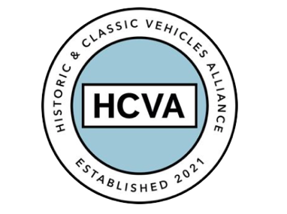

FOR IMMEDIATE RELEASE

28/09/2023

HISTORIC AND CLASSIC VEHICLES ALLIANCE
ANNOUNCES PARTNERSHIP WITH STARTERMOTOR CHARITY

Bicester, Oxfordshire, 28th September 2023 – The Historic and Classic Vehicles Alliance (HCVA), one of Britain’s leading automotive trade bodies known for advocating the preservation, promotion, and enjoyment of historic and classic vehicles, has announced a partnership with StarterMotor.

The collaboration will serve as a catalyst for the delivery of shared objectives and aspirations for the charity and not-for-profit organisation, with common initiatives to engage a younger audience with the classic car industry.

StarterMotor is focused on introducing the next generation to historic motoring, careers and events by providing free resources to individuals, academic establishments and apprenticeship schemes.

Investing in the next generation of historic car enthusiasts and encouraging them to consider careers in the industry is a shared goal of both parties. As such, the partnership agreement between the HCVA and StarterMotor is predicated on promoting the wider understanding of the economic and social benefits of the historic and classic vehicle sector to a dynamic audience of younger people.

Working with members, organisations and like-minded partners to actively advocate career opportunities and encourage learning across the sector forms one of the HCVA’s four core campaign pillars: Education and Skills, which will be spearheaded by StarterMotor’s CEO, David Withers.

HCVA Chair, David Meek says: “Partnering with StarterMotor amplifies the HCVA’s commitment to our Education and Skills campaign pillar, while promoting knowledge, inclusivity, collaboration, and shared experiences. We’re delighted to work with such a commendable and forward-thinking charity, for the mutual benefit of our youth and our industry.”

The Historic and Classic Vehicles Alliance and StarterMotor will collaborate formally for the first time at the HCVA’s upcoming Heritage Matters Day next month (5th October 2023), when their CEO, David Withers and his team will speak about improving education and skills to help secure the classic car industry’s future.

David said: “A partnership with HCVA is a strategic no-brainer for StarterMotor. For the past five years we’ve focused on reaching the next generation, knowing that our old car sector can provide a real haven in the digital world - enjoyment, adventure and community. Together we can accelerate the mission, bringing more and more young people into our world.”

The HCVA is committed to preserving the UK’s rich legacy of historic and classic vehicles, while also making significant strides in safeguarding automotive heritage and inspiring future generations. This new partnership marks an exciting milestone in its journey.

For more information about HCVA and its members, visit our website: www.hcva.co.uk

ENDS

About HCVA

Established in 2021, the Historic and Classic Vehicles Alliance is a not-for-profit trade organisation founded to represent the collective voice of SMEs within the historic and classic vehicle sector, supported by individual owners and enthusiasts.
Through collaboration, transparency, and proactive lobbying the HCVA seeks to increase awareness and education of the sector's economic and social benefits, to ensure those responsible for policy and regulation are challenged and held accountable, to promote sustainable innovation and technologies, and to ensure the HCVA member community is engaged and confident their voices will be heard.

For more information, please contact:

Libby Raynsford
Director of Marketing and Communications

Email: libby@hcva.co.uk
Phone: 07525 372631

