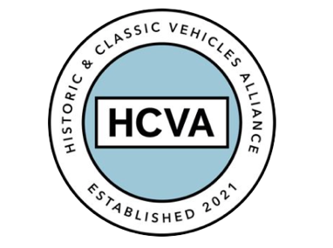

FOR IMMEDIATE RELEASE

27/07/2023

HISTORIC AND CLASSIC VEHICLES ALLIANCE
WELCOMES GOVERNMENT’S INDEPENDENT REVIEW OF DVLA

Bicester, Oxfordshire, 27th July 2023 –The Historic and Classic Vehicles Alliance (HCVA), one of Britain’s leading automotive trade organisations known for advocating the preservation, promotion, and enjoyment of historic and classic vehicles, welcomes the launch of an independent review of the Driver and Vehicle Licensing Agency (DVLA), as announced by Richard Holden MP this week.

The review is part of a wider government programme looking into the effectiveness and efficiency of public bodies and is intended to ensure the DVLA can continue to provide a licensing service to motorists and the public. It will be assessed on four pillars set by the Cabinet Office: efficiency, efficacy, accountability and governance.

The news comes after David Meek, Chair of the HCVA met with Parliamentary Under Secretary of State for Roads and Local Transport, Richard Holden last month. He joined Greg Smith MP, Sir Greg Knight MP, and other industry colleagues at the meeting to highlight concerns around the DVLA’s treatment of the historic and classic vehicles sector.

David says; “This independent review is a very important development for the sector, which will facilitate a refocus on the current effectiveness and lack of transparent decision making and policy at the DVLA. The organisation is well regarded by the industry and recognises its tremendous responsibility, however, HCVA members and partners have multiple case studies that some decisions being taken relating to historic and classic vehicles are proven to be unjustified. Despite industry expert involvement, the current appeals process and oversight of these decisions has been ineffective. We welcome this independent, wide ranging review and offer our expertise, experience and guidance from across the sector we proudly represent.”

Led by Janette Beinart, non-executive director of the Cabinet Office and National Highways, the review will look at how the DVLA works with its stakeholders within and outside of government to help keep Britain’s roads safe.

Integral to HCVA’s purpose is representing its members by directly engaging with MPs, policy makers and stakeholders to ensure existing and proposed regulations are fit for purpose, while offering impartial consultation and expertise. The alliance has engaged with MPs, the Transport Select Committee and the DVLA to lobby for transparent policies, appeal processes and effective oversight since being founded two years ago.

As such, the Alliance is pleased to support the proposed government review of the DVLA.

With over 40 million vehicle records and over 50 million driver records held within the UK government’s arms-length agencies, the Alliance seeks to make certain there is accountable oversight and appropriate challenge where needed.

Since its inception, the HCVA has emerged as a passionate and forward-thinking organisation committed to preserving the UK’s rich legacy of historic and classic vehicles, while also making significant strides in safeguarding automotive heritage and inspiring future generations.

For more information about HCVA and its members, visit our website: www.hcva.co.uk

ENDS

About HCVA

Established in 2021, the Historic and Classic Vehicles Alliance is a not-for-profit trade organisation founded to represent the collective voice of SMEs within the historic and classic vehicle sector, supported by individual owners and enthusiasts.
Through collaboration, transparency, and proactive lobbying the HCVA seeks to increase awareness and education of the sector's economic and social benefits, to ensure those responsible for policy and regulation are challenged and held accountable, to promote sustainable innovation and technologies, and to ensure the HCVA member community is engaged and confident their voices will be heard.

For more information, please contact:

Libby Raynsford
Director of Marketing and Communications

Email: libby@hcva.co.uk
Phone: 07525 372631

