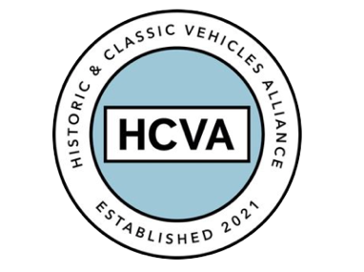

FOR IMMEDIATE RELEASE

06/06/2023

HISTORIC AND CLASSIC VEHICLES ALLIANCE CELEBRATES SECOND ANNIVERSARY

Bicester, Oxfordshire, 6th June 2023 –The Historic and Classic Vehicles Alliance (HCVA), one of Britain’s leading automotive trade organisations known for advocating the preservation, promotion, and enjoyment of historic and classic vehicles, is celebrating its second anniversary.

Marking the milestone, the HCVA is proud to reflect upon its considerable growth during this period, as well as acknowledging its achievements working with government agencies and politicians to successfully chart a vision for the future of the industry.

Established in 2021, the Historic and Classic Vehicles Alliance is a trade membership association built to support SMEs within the classic and historical vehicle sector, supported by the individuals and enthusiasts who benefit from their services.

Since its inception, the HCVA has emerged as a passionate and forward-thinking organisation committed to preserving the UK’s rich legacy of historic and classic vehicles, while also making significant strides in safeguarding automotive heritage and inspiring future generations.

As it continues to build its roadmap for the next two years, the Alliance will further strengthen its vibrant community of passionate enthusiasts through engaging events, educational initiatives, and networking opportunities.

HCVA Chair, David Meek said; “This is an exciting time for the HCVA as we build on the foundations of the last two years and ensure the collective voice of our members is heard and that the tremendous benefits the sector offers are understood by a wider audience”.

Looking ahead, the Historic and Classic Vehicles Alliance is set to embark on the next phase of its journey. It’s vision for the future is grounded in four key pillars:

Environment and sustainability: Working with the broader industry and policy makers to embrace advances in knowledge and technologies to find sustainable solutions for both new and classic vehicles alike.

Education and skills: HCVA promotes the wider understanding of the economic and social benefits of the historic and classic vehicle sector, ensuring a diverse and inclusive industry drives future generations to engage.

The Alliance works hand in hand with members, partners and corporations to actively promote career opportunities within the sector, from engineering to marketing, operations to executive leadership.

Regulation and policy: Directly engaging with MPs, policy makers and stakeholders to ensure that existing and proposed regulations are fit for purpose, offering consultation and transparency throughout their process.

With over 40 million vehicle records and over 49 million driver records held within the UK government’s arms-length agencies, HCVA seeks to ensure there is accountable oversight and appropriate challenge as needed.

Community: Members are central to all the HCVA does and businesses come together to collectively use their voice to make considered representations and impactful change. Information sharing and collaboration between members is actively encouraged.

The not-for-profit organisation currently represents more than 100 SME trade members and is dedicated to ensuring the industry continues to grow and its £18billion contribution to the UK national economy is recognised and continues to grow.

For more information about HCVA and its members, visit our website: www.hcva.co.uk

ENDS

About HCVA

Established in 2021, the Historic and Classic Vehicles Alliance is a not-for-profit trade organisation founded to represent the collective voice of SMEs within the historic and classic vehicle sector, supported by individual owners and enthusiasts.
Through collaboration, transparency, and proactive lobbying the HCVA seeks to increase awareness and education of the sector's economic and social benefits, to ensure those responsible for policy and regulation are challenged and held accountable, to promote sustainable innovation and technologies, and to ensure the HCVA member community is engaged and confident their voices will be heard.

For more information, please contact:

Libby Raynsford
Director of Marketing and Communications

Email: libby@hcva.co.uk
Phone: 07525 372631

