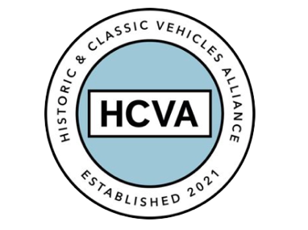

FOR IMMEDIATE RELEASE

10/05/2023

HISTORIC AND CLASSIC VEHICLES ALLIANCE APPOINTS NEW CHAIR OF THE BOARD

Bicester, Oxfordshire, 10th May 2023 – Following his recent appointment, the Historic and Classic Vehicles Alliance (HCVA) is pleased to formally announce David Meek as its new Chair of the Board.

With a background working as an independent chair, non-executive director and CEO across not-for-profit, real estate, finance and technology businesses, including This Land, Ethical Tea Partnership, Twycross Zoo, Science Museum Foundation and as a senior executive at JP Morgan, David’s appointment seeks to strengthen HCVA’s continued period of growth.

In his new role as Chair, David will oversee the wider operations of the HCVA, including its strategic objectives, public engagement, and growth. As such, he will work closely with the company’s executive team and stakeholders to realign strategy and support Alliance members alongside four new core pillars; environment and sustainability, education and skills, regulation and policy, and the HCVA community.

“Over the last 25 years this sector has transitioned from enthusiasts and hobbyists to a multi billion pound industry. Unlike many industries, it is made up solely of small, hard working companies and I am delighted to join HCVA to support them. Our role is to drive change and broader awareness to promote the considerable opportunities within the sector, whilst representing our members to collaboratively address the challenges they are facing.” said David.

Established in 2021, HCVA is a trade membership association built to support SMEs within the classic and historical vehicle sector. It also offers membership to individuals and enthusiasts who use and support their services.

David said: “In the face of an increasingly challenging public and political lack of awareness surrounding classic cars, the role of the HCVA has never been more important. By focussing on our four core pillars, we will further strengthen the case for the historic and classic car sector, both for our members and the wider industry.”

The not-for-profit organisation currently represents more than 100 SME trade members from the £18 billion sector which employs over 110,000 people. The HCVA is dedicated to ensuring the industry continues to grow and its contribution to the UK national economy remains significant.

David’s appointment forms part of a wider focus for HCVA, as the Alliance seeks to a) attract newer, younger audiences and increase engagement and collaboration within the classic car sector, b) lead the drive for innovative, sustainable fuel and technology solutions, and c) ensure policy makers are aware of the challenges faced by HCVA members and the wider historic and classic car community.

“As a lifelong classic car enthusiast, I am delighted to bring my experience to work with our members, policy makers and the wider industry.” Said David.

For more information about HCVA and its members, visit our website: www.hcva.co.uk

ENDS

About HCVA

Established in 2021, the Historic and Classic Vehicles Alliance is a not-for-profit trade organisation founded to represent the collective voice of SMEs within the historic and classic vehicle sector, supported by individual owners and enthusiasts.
Through collaboration, transparency, and proactive lobbying the HCVA seeks to increase awareness and education of the sector's economic and social benefits, to ensure those responsible for policy and regulation are challenged and held accountable, to promote sustainable innovation and technologies, and to ensure the HCVA member community is engaged and confident their voices will be heard.

For more information, please contact:

Libby Raynsford
Director of Marketing and Communications

Email: libby@hcva.co.uk
Phone: 07525 372631

