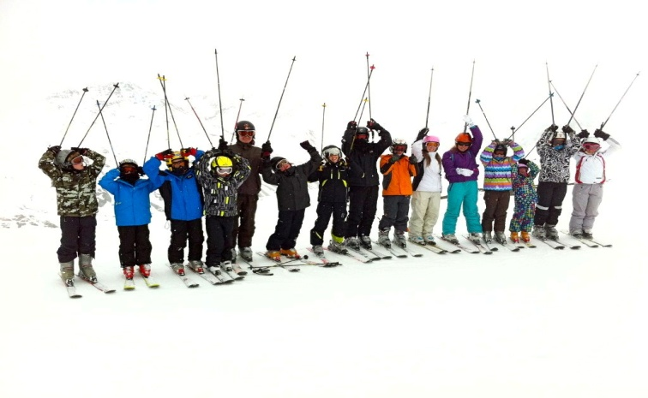

Snowsports and the LOtC Quality Badge

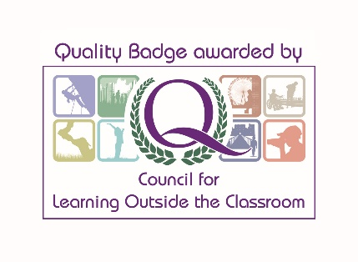
The LOtC Quality Badge, awarded by the Council for Learning Outside the Classroom, provides for the first time a national award combining the essential elements of provision – learning and safety – into ONE easily recognisable and trusted accreditation scheme for ALL types of learning outside the classroom provider organisation.
The School Travel Forum (STF) is the Awarding Body for the Quality Badge Scheme for Ski and Snowsport trips. It is a not-for-profit organisation and operates on shared, non-competitive, good practice issues.
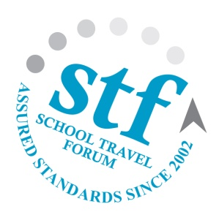
Last year over 80,000 children went on school ski trips organised by School Travel Forum members, an estimated 75% of the total market. In many ways the success of these trips represent the future of snowsports in the UK.

How does the STF scheme work?
Every year all STF Assured Members are audited by independent experts to ensure they are complying with our Code of Practice which includes safety management systems, financial protection requirements and fair trading policies. This is not a simple tick box exercise; we use trained and expert auditors who are entitled to inspect any aspect of our members’ operations. If they don’t measure up then they lose their Assured Member status and can no longer claim membership.
This safety net does not increase costs for the consumer, nor does it restrict choices. There is a wide range of STF Assured Members, large and small, each competing for business in the normal way ensuring choice and healthy competition. Any UK based company can apply to become an Assured Member of the STF, but first they have to meet our standards and be successfully audited; new members are actively helped and encouraged to get up to standard.
For group leaders and their employers, the due diligence needed when choosing a supplier is easily demonstrated when using an STF Assured and Quality Badged supplier as are the other important considerations of work load reductions, peace of mind and confidence in good practice.
All our standards are regularly reviewed and informed by relevant independent experts, a leading law firm which specialises in travel and safety issues and we constantly seek the input of other stakeholders including the Outdoor Education Advisors Panel.
Our standards cover all aspects of and types of tours our members offer and for Snowsports it ensures the following elements are covered:
Accommodation |  | Road Transport |  | Snowsports
Checked by trained & competent auditors | Local standards, licensing & insurance checks | Checked by trained & competent auditors | Support & breakdown arrangements | Instructor qualification and approvals | Suitability of equipment and hire
Fire safety | Bedroom safety | Regulation compliance, licensing & insurance checks | Vehicle inspection and Maintenance | Clear information on class arrangements | Expert fitting of equipment
Security | Food hygiene & Legionella | Vehicle age & suitability | Drivers’ Hours compliance | Suitable lifts and runs | Safety checks on optional excursions
Gas & electrical safety | Slips and trips | Driver suitability checks & training | Suitability for winter conditions | Clothing advice and guidance | UK consumer protection overriding local disclaimers
Management competence and staff training | Suitability for children and winter conditions | Management competence and staff training |  | Helmets
Financial Protection |  |  | …and if things do go wrong
Financial protection through STF approved schemes only |  |  | 24hr Duty Officer and full emergency procedures
Full ATOL protection for air tours |  |  | Accidents, incidents & near miss review with a high level review process
Fair terms & conditions and clear offer letters |  |  | Published complaints procedure linked into STF’s complaints process
Minimum Tour Operator’s Liability Insurance of £5m |  |  | Commitment to ultimate dispute arbitration

If you require more information please visit www.schooltravelforum.com, or write to us at info@schooltravelforum.com

