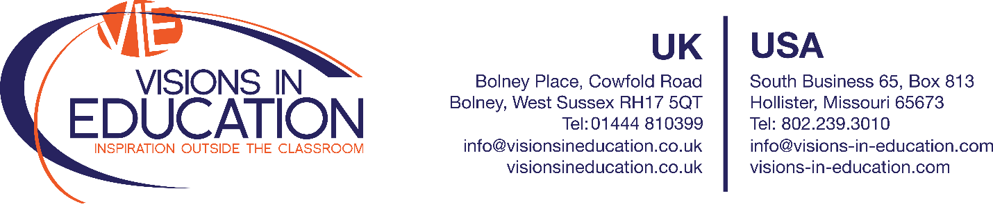

Visions in Education is delighted to announce that

School

Of

City / State

Has been selected to represent STATE in a specialty STEM (Science, Technology, Engineering and Mathematics) educational opportunity to destination in year.

The students participating will be required to engage with local scientists and educational workshop facilitators for STEM study Master Classes and further scientific education.

It is our hope that you will help support these pupils in their fundraising efforts by contributing to their resources to allow them to raise the required funds for travel.

If we may be of assistance or provide any details to you about this incredible scientific opportunity and how it relates to the fundraising efforts of school, please do not hesitate to contact us directly.

Very warmest regards,

Michele
Michele Hammock
International Director & USA General Manager
Visions in Education
Main USA: 802.239.3010 / Main UK: 01444 226348
Email: michelehammock@visions-in-education.com
Web: www.visionsineducation.co.uk / www.visions-in-education.com

